Projected Nominations Timeline

**11/7 12/1 12/16 12/23 12/30 1/6 1/13 1/20 1/27**

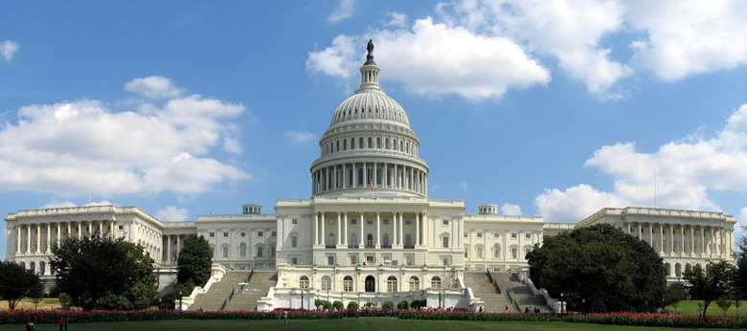

**Official announcement, Nominee meets NST**

**Target confirmation**

**Target hearing dates**

**Murder board prep**

**Nominee makes courtesy visits to the Hill**

**Nominee begins policy prep**

**WHC and FBI clear nominee**

**President Selects Nominee. Vetting process begins**